Teacher: Raphael Essoh | Course: French
Room: 215 | Email: essohr@scsk12.org

Course Description:
The word Language program at MSCS focuses on using language in real- word situations. Students learn language that prepares them to communicate with others through oral language, print, and media. Although students will need to know vocabulary, grammar, and cultural information, they learn to use them purposefully for communication with others. This emphasis on communication aligns with the MSCS curriculum, state and national standards

Expectations and Goals:
At each level of word language instruction, students expand the topics on which they can communicate, the ways in which they can express themselves and understand others, and the sophistication with which they can express ideas. Students’ understanding of other cultures, ability to behave in culturally acceptable ways, and to recognize the relationship between language and culture grow with each unit, year, and level of world language study.

Required Materials: Book : T’Es Branche
A notebook, a binder or a folder, as a pen or a pencil.

Classroom Rules, Procedures, Policies/Consequences:
Be respectful
Listen when others are talking
Keep hands and feet to yourself

Students are expected to come to class on time and read their notebooks. They are also required to ask for permission before they go to the restrooms or get out of the class.
Failure to comply with these rules and procedures will lead to verbal warning, a phone call to the parents, and disciplinary referral.

Grading Policy:

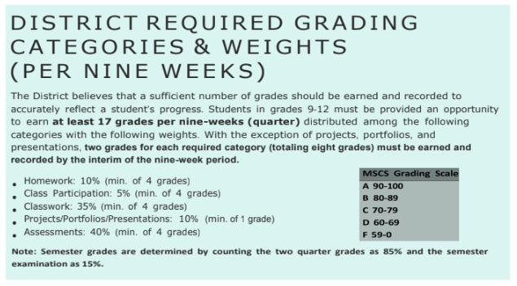

Makeup Work Policy:

It should be the primary responsibility of students/parents to obtain the makeup work provided and to complete it in the allotted time to receive full credit earned without point reduction.

If a student has an excused absence, he/she has a total of 3 days for each excused day to submit makeup work (beginning the day after the student returns to school).

If a student had an unexcused absence (including short-term suspensions), he/she has a total of 1 day for each day unexcused to submit makeup work (beginning the day after the student returns to school). The highest grade a student may receive when the absence is unexcused is a 60/D.

A student cutting class will not be allowed to complete makeup work. A Student cutting class will have the opportunity to take advantage of grade repair at the end of the nine-week period.

A designated space in the room will be available for students to obtain makeup assignments. Teachers must assign a due date for each assignment.

Once makeup assignments are obtained, students/parents must sign off that the work has been received. Late makeup work will not be accepted.

Tutoring:

.

Statement of Recognition and Agreement

As the parent/guardian of______________________________________________, I have read and understand the classroom rules, polices, and procedures with my child. Should I have any questions or concerns, I may contact the teacher via phone or email, and/or schedule a conference with the teacher.

Student Signature Date

Parent/Guardian Signature Date

